This function arises in many dynamical systems because it is the solution to a first order differential equation:
dx / dt = k x - a x2
It is expressed in the form:
f(x) = 1/(1 + e-ax)
A graph of this function is shown in Figure 1 following:
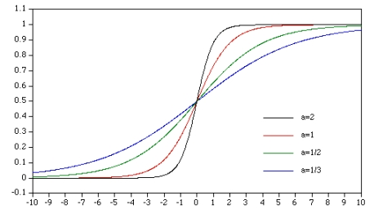
Figure 1
Sigmoid Function
Figure 1 was taken from reference 1. Reference 2 provides a neat little graphic that shows the effects of modifying the parameters.
Modified Half Sigmoid Function Model:
Let us make a few assumptions as a basis for the model. The first is that the input signal will range in value from at least MinV as a minimum to at least MaxV as a maximum. At an input equal in magnitude to MinV the output should be minimum and at an input equal in magnitude to MaxV the output should be maximum. The modified Signoid curve of the previous paper was:
S(a,x.MaxVAL, MinVAL, MaxV, MinV) = MinVAL +2*MaxVAL*(1/(1+e-(a*(x-Vmid)))-0.5)
where a = 12/(MaxV)
The previous paper showed how one could use this model to vary between a very small to a very large value, however, the curve was effectively offset such that one input transition effectively started or ended at the curve midpoint, and the transitions did not show gradual transitions to and from that point. The manner by which we will transform the input is by the formula:
xt = MinV + 2*x/MaxV
Assuming that the MinV equals -1 (and MaxV equals 1), we add to MinV twice the proportionate amount of the value represented by the quotient of the unmodified input x and MaxV. Again, we assumed the input will range from zero to some positive value equal to or greater than one.
This will be used to produce an output that will vary in a Sigmoid type fashion. With these transformed values, which will range from -1 to 1 (or greater) we can produce a curve that will vary smoothly from a minimum to a maximum value Two equations will be solved, of the form:
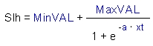
and
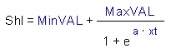
A typical graph of these curves is shown in the following Figure 2:
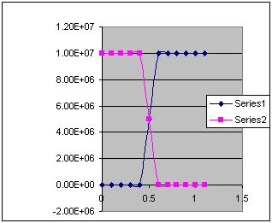
Figure 2
Modified Half Sigmoid Spreadsheet Graph
The Slh function curve is in blue, while the Shl curve is in violet. The two curves arise from the fact that there is odd symmetry of the function - that is, f(x) = -f(-x).
A SPICE model of a circuit which will implement this relation is shown in Figure 3 following:
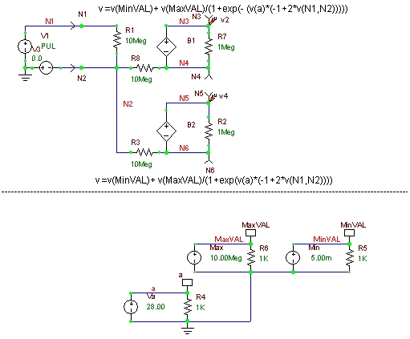
Figure 3
Modified Sigmoid Test Circuit
The equations programmed into the B1 and B2 generators are shown above and below those respective elements. The test circuitry consists of the elements below the dashed line, as well as V1 and V3 sources with the ground. The V3 source is a zero volt generator, used just to maintain the N2 node identity.
It is intended later that the values of 'a', MaxVAL and MinVAL will be parameters passed to the subcircuit.
A netlist of the circuit is as follows:
ModifiedHalf Sigmoid curve.cpr
*
*Created by Harvey Morehouse
*
*B2SPICE VER 4.X AND 5.X compatible
***** main circuit
R1 N1 N2 10Meg
Va a 0 2.800000000000e+001
VMin MinVAL 0 5.000000000000e-003
VMax MaxVAL 0 1.000000000000e+007
R3 N2 N6 10Meg
R4 a 0 1K
R5 MinVAL 0 1K
R6 MaxVAL 0 1K
R2 N5 N6 1Meg
B2 N5 N6 v =v(MinVAL)+ v(MaxVAL)/(1+exp(v(a)*(-1+2*v(N1,N2))))
B1 N3 N4 v =v(MinVAL)+ v(MaxVAL)/(1+exp(- (v(a)*(-1+2*v(N1,N2)))))
R7 N3 N4 1Meg
R8 N2 N4 10Meg
V1 N1 0 PULSE( 0.000000000000e+000 5.000000000000e+000 0.000000000000e+000 5.000000000000e-005 5.000000000000e-005 5.000000000000e-004 1.000000000000e-003)
V3 0 N2 0.000000000000e+000
.TRAN 5E-8 0.002 0 1E-7 uic
.OPTIONS method = trap
.end
The model itself is fairly straightforward, and conforms to the previously developed equations. A graph of the output from the circuit is shown in the following Figure 4.
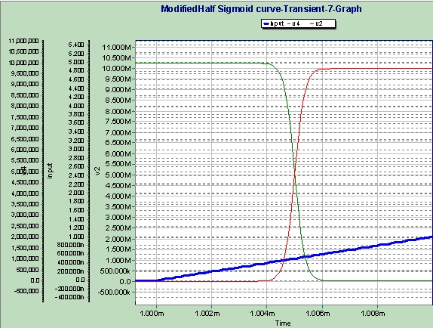
Figure 4
Modified Sigmoid Test Circuit Graph 1
The expanded trace shows a portion of the input leading edge in blue. The red trace is the Slh curve output, whereas the green curve is the Shl output. It is not apparent from the graph, however, the Slh output value is at 5.007mV until the start of the input voltage rise, and the Shl output is at 10M. After the input reaches about 420mV the outputs start to transition and are essentially complete by the time the input is at about 620 mV. The curves are well behaved, and switching is essentially completed in about 2µ sec.
Conclusions:
A Modified Half Sigmoid circuit model has been created which can be useful in creating devices or functions that smoothly switch between different magnitude values. It is assumed that the control input will switch between zero and some positive level. It is assumed that switching during the input rise and fall times is desired, but there is no specific need to tailor this rise time, although through the use of the 'a' parameter and the input rise time some crude control may be achieved. This device should be added to the standard library as a building block.
Later articles are planned that will show how this model and the Modified Full Sigmoid circuit model can be used to create smooth switches, square loop core models, voltage limiters and simple relays, time permitting.
References:
1 http://astronomy.swin.edu.au/~pbourke/other/sigmoid/
2 http://www.ii.metu.edu.tr/~ion526/demo/java/NNOC/Sigmoid.html

Contact Us | Email Updates | Report Errors
Beige Bag Software, Inc., 623 W. Huron, Suite 2, Ann Arbor, MI, 48103  (phone) 734.332.0487 (fax) 734.332.0392 (email) info@beigebag.com | © 2005-2010 Beige Bag Software, Inc

